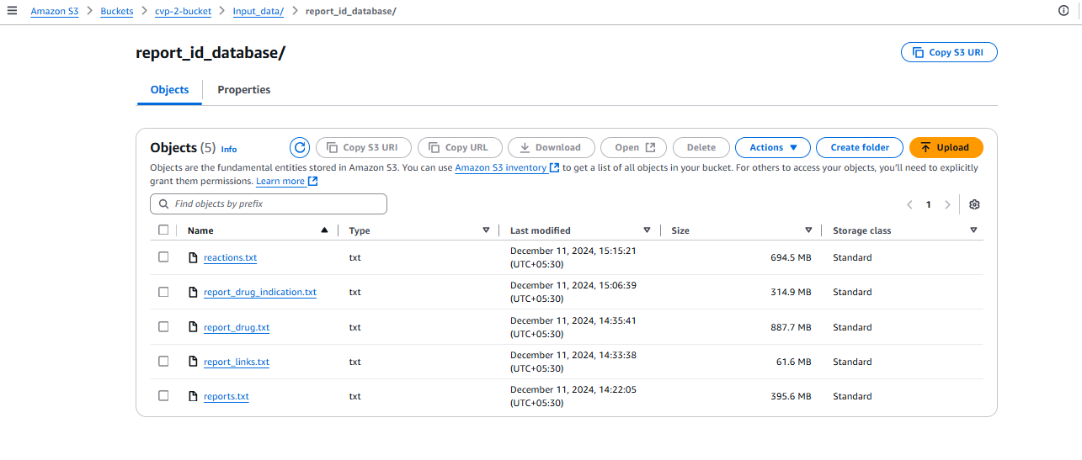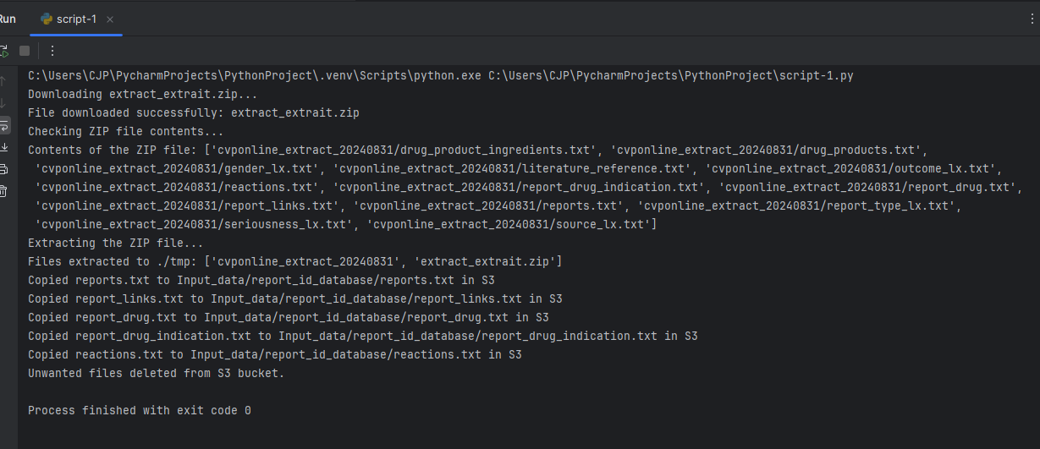  
  
it took almost one hour to run the code script -1

C:\Users\CJP\PycharmProjects\PythonProject2\.venv\Scripts\python.exe C:\Users\CJP\PycharmProjects\PythonProject2\script2.py

2024-12-12 19:57:54,824 - INFO - Found credentials in shared credentials file: ~/.aws/credentials

2024-12-12 19:57:55,211 - INFO - Starting process...

2024-12-12 19:57:55,211 - INFO - Attempting to read S3 file Input_data/Suspected_Product_Brand_Name/drug_names.txt from bucket cvp-2-bucket...

2024-12-12 19:57:56,541 - INFO - Successfully read S3 file Input_data/Suspected_Product_Brand_Name/drug_names.txt from bucket cvp-2-bucket.

2024-12-12 19:57:56,543 - INFO - Parsing drug names...

2024-12-12 19:57:56,543 - INFO - Parsed 2 drug names.

2024-12-12 19:57:56,545 - INFO - Attempting to read S3 file Input_data/report_id_database/report_drug.txt from bucket cvp-2-bucket...

2024-12-12 19:57:56,888 - INFO - Successfully read S3 file Input_data/report_id_database/report_drug.txt from bucket cvp-2-bucket.

2024-12-12 20:25:07,731 - INFO - Finding REPORT_IDs for 2 drug names...

2024-12-12 20:25:38,403 - INFO - Found 374 report IDs matching the drug names.

2024-12-12 20:25:38,403 - INFO - Extracting report data from reference files...

2024-12-12 20:25:38,404 - INFO - Reading reports.txt...

2024-12-12 20:25:38,404 - INFO - Attempting to read S3 file Input_data/report_id_database/reports.txt from bucket cvp-2-bucket...

2024-12-12 20:25:39,890 - INFO - Successfully read S3 file Input_data/report_id_database/reports.txt from bucket cvp-2-bucket.

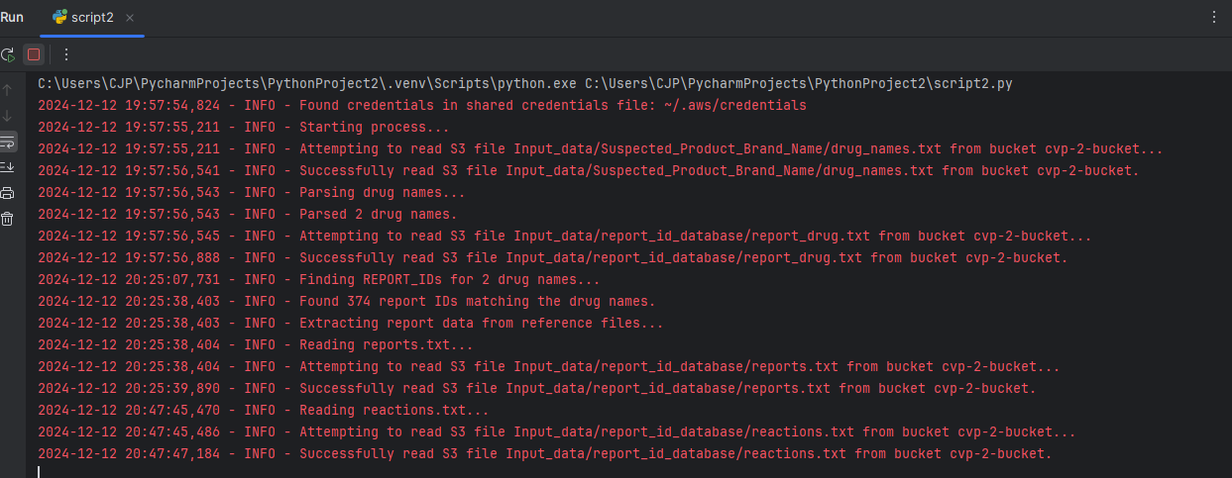

import boto3 import json import logging from collections import defaultdict import time  
  
# Initialize logging and S3 client  
logging.basicConfig(level=logging.INFO, format='%(asctime)s - %(levelname)s - %(message)s')  
s3_client = boto3.client('s3')  
  
# Input and output S3 buckets  
input_bucket = 'cvp-2-bucket'  
output_bucket = 'cvp-2-output'  
  
# File paths in S3  
drug_names_file = 'Input_data/Suspected_Product_Brand_Name/drug_names.txt'  
report_drug_file = 'Input_data/report_id_database/report_drug.txt'  
reports_file = 'Input_data/report_id_database/reports.txt'  
reactions_file = 'Input_data/report_id_database/reactions.txt'  
report_links_file = 'Input_data/report_id_database/report_links.txt'  
report_drug_indication_file = 'Input_data/report_id_database/report_drug_indication.txt'  
  
  
# Function to read files from S3  
def read_s3_file(bucket, key):  
 try:  
 logging.info(f"Attempting to read S3 file {key} from bucket {bucket}...")  
 response = s3_client.get_object(Bucket=bucket, Key=key)  
 logging.info(f"Successfully read S3 file {key} from bucket {bucket}.")  
 return response['Body'].read().decode('utf-8').splitlines()  
 except Exception as e:  
 logging.error(f"Error reading S3 file {key} from bucket {bucket}: {e}")  
 return []  
  
  
# Step 1: Parse drug names from file  
def parse_drug_names(file_content):  
 logging.info("Parsing drug names...")  
 drug_names = []  
 for line in file_content:  
 line = line.strip().lower() # Case-insensitive parsing  
 if line:  
 drug_names.append(line)  
 logging.info(f"Parsed {len(drug_names)} drug names.")  
 return drug_names  
  
  
# Step 2: Locate REPORT_IDs corresponding to drug names  
def find_report_ids(drug_names, report_drug_content):  
 logging.info(f"Finding REPORT_IDs for {len(drug_names)} drug names...")  
 report_ids = defaultdict(list)  
 for line in report_drug_content:  
 fields = line.split('$')  
 if len(fields) > 1:  
 drug_name = fields[3].strip().lower()  
 report_id = fields[1].strip()  
 if any(drug_name in line.lower() for drug_name in drug_names):  
 report_ids[report_id].append(fields)  
 logging.info(f"Found {len(report_ids)} report IDs matching the drug names.")  
 return report_ids  
  
  
# Step 3: Extract data from reference files based on REPORT_ID  
def extract_report_data(report_ids):  
 logging.info("Extracting report data from reference files...")  
 report_data = {}  
  
 # Read reports.txt  
 logging.info("Reading reports.txt...")  
 reports_content = read_s3_file(input_bucket, reports_file)  
 for line in reports_content:  
 fields = line.split('$')  
 if len(fields) > 1:  
 report_id = fields[0].strip()  
 if report_id in report_ids:  
 report_data[report_id] = {  
 'report_no': fields[1],  
 'version_no': fields[2],  
 'datintreceived': fields[4],  
 'datreceived': fields[3],  
 'source_eng': fields[37],  
 'mah_no': fields[5],  
 'report_type_eng': fields[7],  
 'reporter_type_eng': fields[34],  
 'seriousness_eng': fields[26],  
 'death': fields[28],  
 'disability': fields[29],  
 'congenital_anomaly': fields[30],  
 'life_threatening': fields[31],  
 'hospitalization': fields[32],  
 'other_medically_imp_cond': fields[33],  
 'age': fields[12],  
 'gender_eng': fields[10],  
 'height': fields[22],  
 'weight': fields[19],  
 'outcome_eng': fields[17]  
 }  
  
 # Read reactions.txt  
 logging.info("Reading reactions.txt...")  
 reactions_content = read_s3_file(input_bucket, reactions_file)  
 for line in reactions_content:  
 fields = line.split('$')  
 report_id = fields[1].strip()  
 if report_id in report_ids:  
 report_data[report_id]['reaction_eng'] = fields[3]  
 report_data[report_id]['version'] = fields[10]  
 report_data[report_id]['duration'] = fields[9]  
  
 # Read report_links.txt and add data to report_data  
 logging.info("Reading report_links.txt...")  
 report_links_content = read_s3_file(input_bucket, report_links_file)  
 for line in report_links_content:  
 fields = line.split('$')  
 report_id = fields[1].strip()  
 if report_id in report_ids:  
 report_data[report_id]['link_type_eng'] = fields[1]  
 report_data[report_id]['e2b_report_no'] = fields[2]  
  
 # Read report_drug_indication.txt and add data to report_data  
 logging.info("Reading report_drug_indication.txt...")  
 report_drug_indication_content = read_s3_file(input_bucket, report_drug_indication_file)  
 for line in report_drug_indication_content:  
 fields = line.split('$')  
 report_id = fields[1].strip()  
 if report_id in report_ids:  
 report_data[report_id]['indication_eng'] = fields[8]  
  
 # Read report_drug.txt and add data to report_data  
 logging.info("Reading report_drug.txt...")  
 report_drug_content = read_s3_file(input_bucket, report_drug_file)  
 for line in report_drug_content:  
 fields = line.split('$')  
 if len(fields) > 1:  
 report_id = fields[1].strip()  
 if report_id in report_ids:  
 # Add the new data fields from report_drug.txt  
 report_data[report_id]['drug_name_eng'] = fields[3] # DRUG_NAME_ENG  
 report_data[report_id]['drug_type_eng'] = fields[5] # DRUG_TYPE_ENG  
 report_data[report_id]['dose_unit_eng'] = fields[8] # DOSE_UNIT_ENG  
 report_data[report_id]['route_eng'] = fields[16] # ROUTE_ENG  
 report_data[report_id]['dose'] = fields[7] # DOSE  
 report_data[report_id]['freq'] = fields[10] # FREQ  
 report_data[report_id]['therapy_duration'] = fields[13] # DURATION  
  
 logging.info(f"Extracted data for {len(report_data)} report IDs.")  
 return report_data  
  
  
# Step 4: Generate the JSON structure and save it to the output S3 bucket  
def generate_json_output(report_data):  
 logging.info("Generating JSON output...")  
 final_data = []  
 for report_id, data in report_data.items():  
 final_data.append({  
 "report_id": report_id,  
 "report_no": data.get('report_no', ''),  
 "version_no": data.get('version_no', ''),  
 "datintreceived": data.get('datintreceived', ''),  
 "datreceived": data.get('datreceived', ''),  
 "source_eng": data.get('source_eng', ''),  
 "mah_no": data.get('mah_no', ''),  
 "report_type_eng": data.get('report_type_eng', ''),  
 "reporter_type_eng": data.get('reporter_type_eng', ''),  
 "seriousness_eng": data.get('seriousness_eng', ''),  
 "death": data.get('death', ''),  
 "disability": data.get('disability', ''),  
 "congenital_anomaly": data.get('congenital_anomaly', ''),  
 "life_threatening": data.get('life_threatening', ''),  
 "hospitalization": data.get('hospitalization', ''),  
 "other_medically_imp_cond": data.get('other_medically_imp_cond', ''),  
 "age": data.get('age', ''),  
 "gender_eng": data.get('gender_eng', ''),  
 "height": data.get('height', ''),  
 "weight": data.get('weight', ''),  
 "outcome_eng": data.get('outcome_eng', ''),  
 "reaction_eng": data.get('reaction_eng', ''),  
 "version": data.get('version', ''),  
 "duration": data.get('duration', ''),  
 "link_type_eng": data.get('link_type_eng', ''),  
 "e2b_report_no": data.get('e2b_report_no', ''),  
 "drug_name_eng": data.get('drug_name_eng', ''),  
 "drug_type_eng": data.get('drug_type_eng', ''),  
 "dose_unit_eng": data.get('dose_unit_eng', ''),  
 "route_eng": data.get('route_eng', ''),  
 "dose": data.get('dose', ''),  
 "freq": data.get('freq', ''),  
 "therapy_duration": data.get('therapy_duration', ''),  
 "indication_eng": data.get('indication_eng', '')  
 })  
  
 try:  
 json_data = json.dumps(final_data, indent=4)  
 timestamp = time.strftime('%Y%m%d-%H%M%S')  
 output_file_key = f'output_{timestamp}.json'  
 logging.info(f"Uploading JSON data to S3 as {output_file_key}...")  
 s3_client.put_object(Bucket=output_bucket, Key=output_file_key, Body=json_data)  
 logging.info(f"Successfully uploaded JSON data to S3 as {output_file_key}.")  
 except Exception as e:  
 logging.error(f"Error uploading JSON data to S3: {e}")  
  
  
# Main function  
def main():  
 logging.info("Starting process...")  
  
 # Step 1: Read and parse drug names  
 drug_names_content = read_s3_file(input_bucket, drug_names_file)  
 drug_names = parse_drug_names(drug_names_content)  
  
 # Step 2: Find report IDs for the parsed drug names  
 report_drug_content = read_s3_file(input_bucket, report_drug_file)  
 report_ids = find_report_ids(drug_names, report_drug_content)  
  
 # Step 3: Extract data for each report ID  
 report_data = extract_report_data(report_ids)  
  
 # Step 4: Generate JSON and upload to S3  
 generate_json_output(report_data)  
  
 logging.info("Process completed.")  
  
if __name__ == "__main__":  
 main()

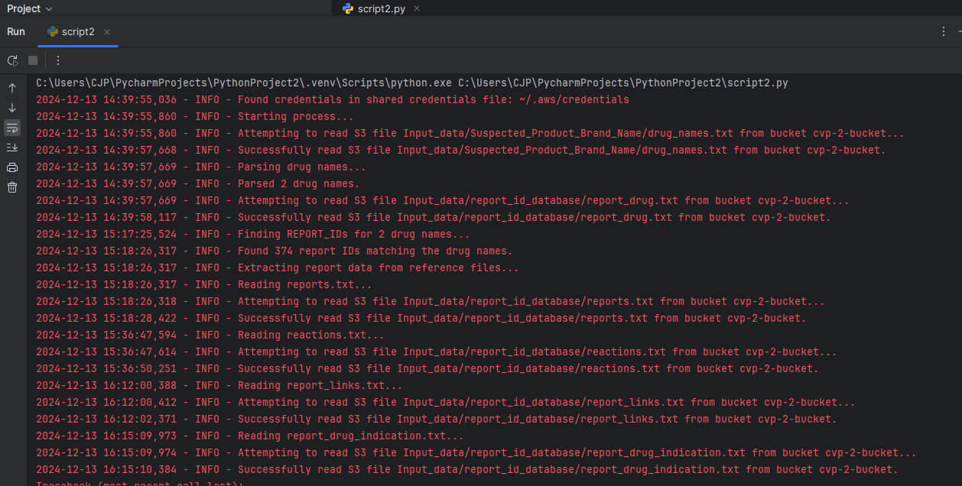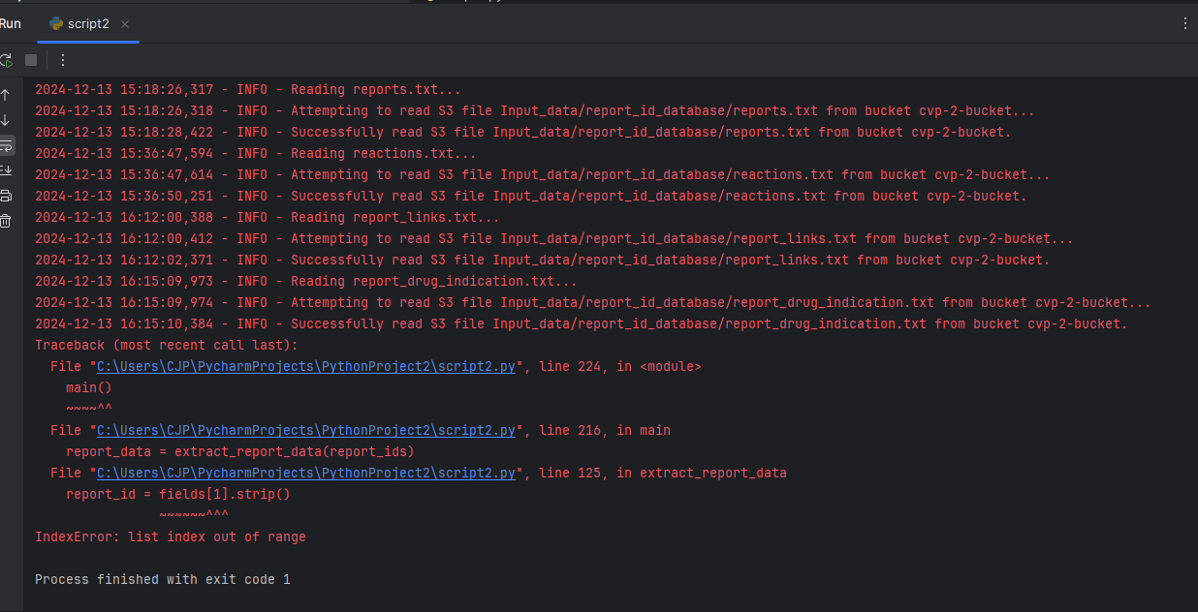

**Script3**

C:\Users\CJP\PycharmProjects\PythonProject3\.venv\Scripts\python.exe C:\Users\CJP\PycharmProjects\PythonProject3\script3.py 2024-12-13 15:48:09,873 - INFO - Found credentials in shared credentials file: ~/.aws/credentials 2024-12-13 15:48:10,246 - INFO - Attempting to read S3 file Input_data/Suspected_Product_Brand_Name/drug_names.txt from bucket cvp-2-bucket... 2024-12-13 15:48:10,251 - INFO - Attempting to read S3 file Input_data/report_id_database/report_drug.txt from bucket cvp-2-bucket... 2024-12-13 15:48:10,254 - INFO - Attempting to read S3 file Input_data/report_id_database/reports.txt from bucket cvp-2-bucket... 2024-12-13 15:48:10,257 - INFO - Attempting to read S3 file Input_data/report_id_database/reactions.txt from bucket cvp-2-bucket... 2024-12-13 15:48:10,259 - INFO - Attempting to read S3 file Input_data/report_id_database/report_links.txt from bucket cvp-2-bucket... 2024-12-13 15:48:10,261 - INFO - Attempting to read S3 file Input_data/report_id_database/report_drug_indication.txt from bucket cvp-2-bucket... 2024-12-13 15:48:12,939 - INFO - Successfully read S3 file Input_data/Suspected_Product_Brand_Name/drug_names.txt from bucket cvp-2-bucket. 2024-12-13 15:48:12,940 - INFO - Finished reading drug_names. 2024-12-13 15:48:12,959 - INFO - Successfully read S3 file Input_data/report_id_database/reactions.txt from bucket cvp-2-bucket. 2024-12-13 15:48:13,002 - INFO - Successfully read S3 file Input_data/report_id_database/report_links.txt from bucket cvp-2-bucket. 2024-12-13 15:48:13,105 - INFO - Successfully read S3 file Input_data/report_id_database/report_drug_indication.txt from bucket cvp-2-bucket. 2024-12-13 15:48:13,126 - INFO - Successfully read S3 file Input_data/report_id_database/report_drug.txt from bucket cvp-2-bucket. 2024-12-13 15:48:13,146 - INFO - Successfully read S3 file Input_data/report_id_database/reports.txt from bucket cvp-2-bucket. 2024-12-13 16:36:49,476 - INFO - Finished reading report_drug. 2024-12-13 16:36:49,515 - INFO - Finished reading reports. 2024-12-13 16:36:49,516 - INFO - Finished reading reactions. 2024-12-13 16:36:49,516 - INFO - Finished reading report_links. 2024-12-13 16:36:49,516 - INFO - Finished reading report_drug_indication. 2024-12-13 16:36:49,516 - INFO - Drug names file size: 4 lines 2024-12-13 16:36:49,517 - INFO - Report drug file size: 4953547 lines 2024-12-13 16:36:49,517 - INFO - Reports file size: 1136110 lines 2024-12-13 16:36:49,517 - INFO - Reactions file size: 4392489 lines 2024-12-13 16:36:49,517 - INFO - Report links file size: 1294010 lines 2024-12-13 16:36:49,517 - INFO - Report drug indication file size: 3222924 lines 2024-12-13 16:36:49,518 - INFO - Parsing drug names... 2024-12-13 16:36:49,519 - INFO - Parsed 2 drug names. 2024-12-13 16:36:49,520 - INFO - Finding REPORT_IDs for 2 drug names... 2024-12-13 16:38:03,102 - INFO - Found 374 report IDs matching the drug names. 2024-12-13 16:38:03,112 - INFO - Extracting report data from reference files... Traceback (most recent call last): File "C:\Users\CJP\PycharmProjects\PythonProject3\script3.py", line 255, in <module> main() ~~~~^^ File "C:\Users\CJP\PycharmProjects\PythonProject3\script3.py", line 242, in main report_data = extract_report_data( report_ids, ...<4 lines>... results['report_drug'] ) File "C:\Users\CJP\PycharmProjects\PythonProject3\script3.py", line 110, in extract_report_data report_id = fields[1].strip() ~~~~~~^^^ IndexError: list index out of range Process finished with exit code 1

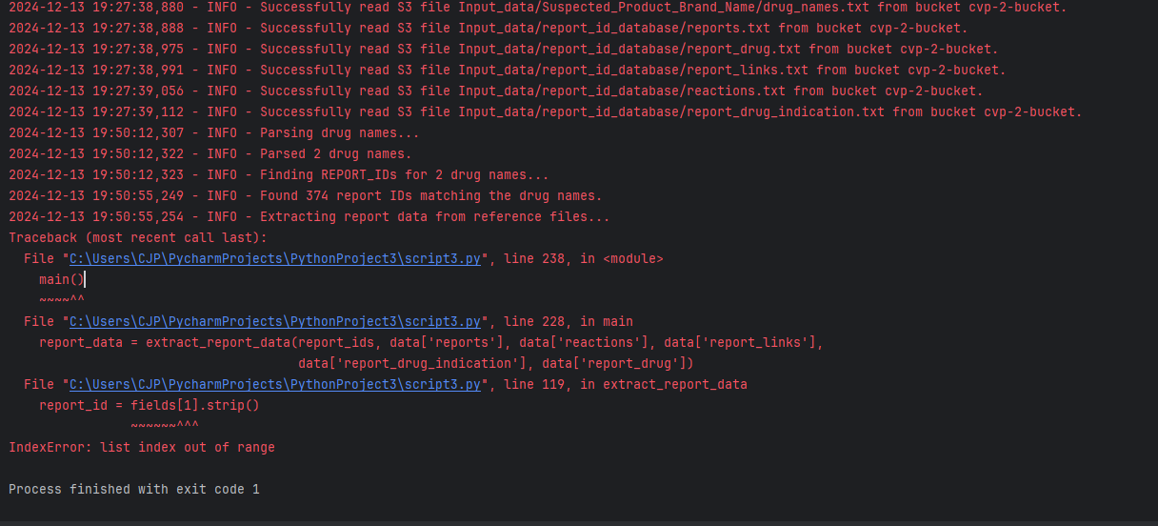

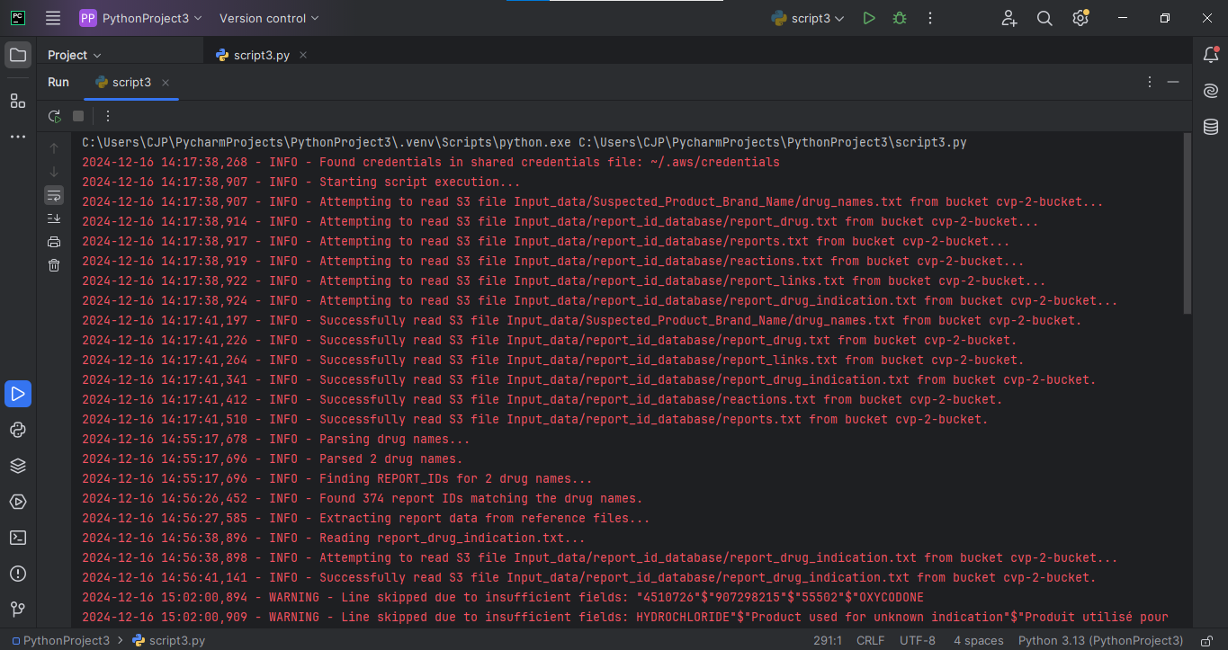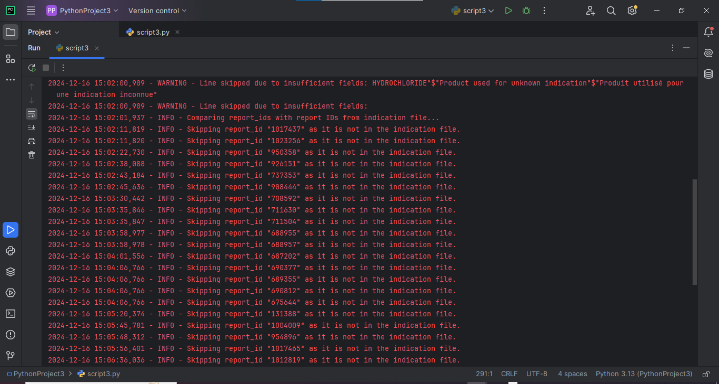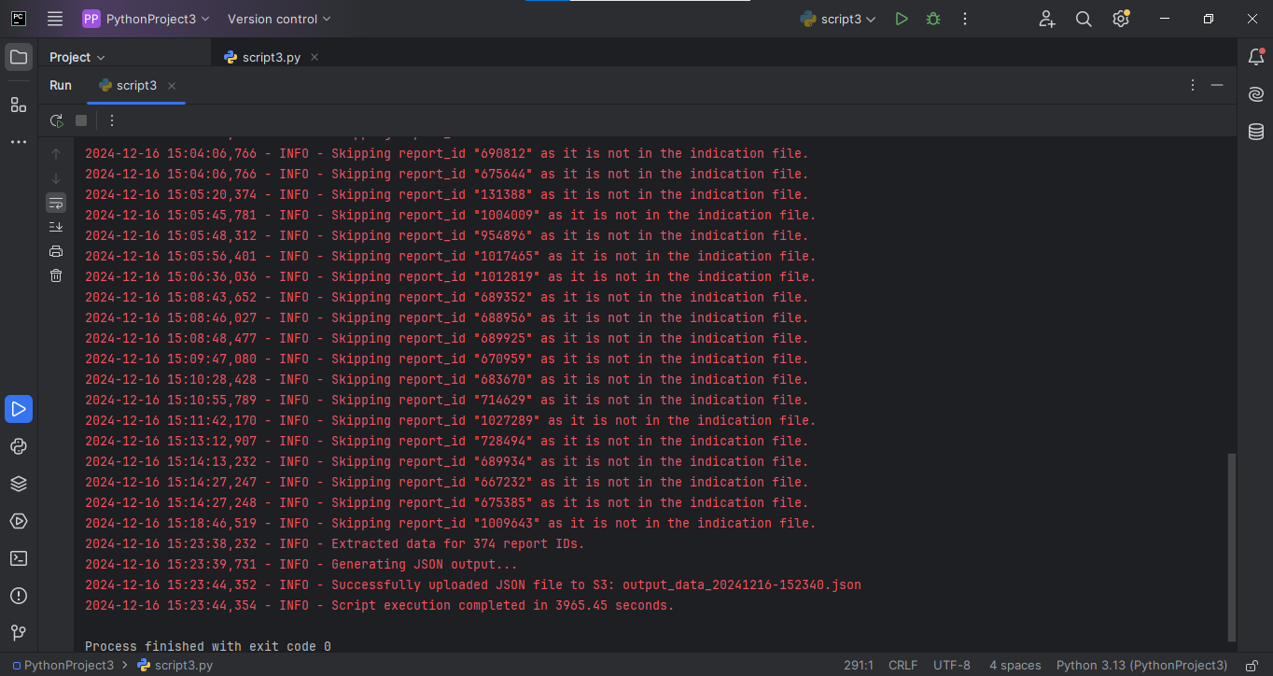

Script2 15:38

